A generalized tool for deriving connectomes in support of computational neuroscience
By
David Mattie
Submitted in partial fulfillment of the
requirements for the degree of
Masters of Science in Computer Science
at
Saint Francis Xavier University
Antigonish, Nova Scotia
May 2019
© Copyright by David Mattie, 2019
Saint Francis Xavier University
Department of
Mathematics, Statistics and Computer Science
The undersigned hereby certify that they have read a thesis entitled “A Generalized Tool for Deriving Connectomes in Support of Computational Neuroscience” by David Mattie in partial fulfillment of the requirements for the degree of Masters of Science in Computer Science.

Dated:

Supervisor:
Dr. Jacob Levman

Second Reader:
Dr. TBD

St. Francis Xavier University
May 2019
Author: David Mattie
Title: A Generalized Tool for Deriving Connectomes in Support of Computational Neuroscience
Department: Mathematics, Statistics and Computer Science
Faculty: Science
Convocation: May 2019
Permission is herewith granted to Saint Francis Xavier University to circulate and to have copied for non-commercial purposes, at its direction, the above title upon request of individuals or institutions.

David Mattie

The author reserves other publication rights, and neither the thesis nor extensive extractions from it may be printed or otherwise reproduced without the author's written permission.
The Author attests that permissions has been obtained for the use any copyrighted material appearing in this thesis (other then of brief excerpts requiring only proper acknowledgement in scholarly writing) and that all such use is clearly acknowledged.
to Dad
Abstract
This research establishes a framework in which to perform connectomic measurements of tens of thousands of data points across all major brain regions. A user shell was developed to derive these connectomes, and then provide mechanisms to quickly extract and analyze the calculated data of interest. Machine learning algorithms have demonstrate the application of computational neuroscience through pattern discovery. The tool supports the extraction of data for multiple uses.
Acknowledgements
I would like to express my gratitude to my advisor Dr. Jacob Levman PhD, for giving me the opportunity for this thesis. His sharing of knowledge across many facets of the material has been helpful and encouraging. I would also like to thank Dr. James Hughes for his knowledge of machine learning and data mining. Finally, Dr. Iker Gondra for his broad experience with image parcellation and artificial intelligence.
Contents
Introduction 1
Hyopthesis 1
Relevance 1
Tractography 1
Current technology landscape 1
Technology Roadmap 1
Current Landscape of Connectomics 1
Machine Learning Applications 1
Techology Landscape 1
Preliminary Discussion and Results 1
Implementation 1
Technology and Tools 1
CRUSH 1
User Interface 1
Measurement Extraction Pipeline 1
Data 1
Patient Data 1
Capture Hardware 1
Measurement Data 1
Extraction 1
SQL Access 1
Demonstration of Analysis 1
System Architecture 1
Conclusion 1
Results – Testing, Statistics, Proof of Accuracy 1
Challenges and Issues Encountered 1
Resource Limitations 1
CEDAR 1
GRAHAM 1
Alienware 1
Dell Precision Tower (40 core) 1
Disk Contention 1
Proposed Enhancements 1
Map Reduce 1
REDIS 1
Improved Fault Detection 1
Add Pre-Pipeline Phase 1
Final Remarks 1

Introduction
The structure of the human brain is extraordinarily complicated, in part because of how interconnected neurons extend between brain regions. Patterns of neural development and neuronal migration make the assessment of _ber tracts in the developing brain particularly challenging. Studying the structure and synaptic connections within the brain has been in practice since the 1970s, however it has only recently become possible to acquire and process the unprecedented quantity of data and measurements produced at a macro level in the brains of real-world clinical patients. Analysis of the entire connectome (a representation of the physical connections apparent in a patient's brain) is within reach as computational power, acquisition technologies and storage capabilities mature.
In recent years, there have been dozens of tools developed to extract measures from magnetic resonance imaging (MRI) data, such as FSL and TrackVis for conducting functional MRI (fMRI), MRI, diffusion tensor imaging (DTI), and fiber tract analyses. While diverse in functionality, these tools tend to be focused on specific functional capabilities, such as eddy_correct, a tool for correcting eddy currents from diffusion data. When combined with other tools to form a workow pipeline, it becomes possible to achieve complex renderings of imaging data that may play a key role in improving our understanding of healthy brain development, abnormal brain development and to measure the brain's physical connections.
This research leverages existing tools while creating novel pipelines to accomplish two objectives: First, provide the capability to conduct a cartesian product fiber tract analysis among a wide range of regions of interest (ROIs). Second, to provide a mechanism for conducting a rapid extract of inter-ROI measurements from all sample data. This tool establishing future research into understanding relationships among ROIs, the degree of connectivity associated with any two region pairs, and determining any possible correlation with physiological conditions such as gender, age, or disorders such as autism.

Hyopthesis
It is possible to derive thousands of measures such as fiber tract length, fractional
anisotrophy, fiber tract count and apparent diffusion coeffcient across an exhaustive
list of ROI pairs to support the neuroscientific analysis of brain development as well as
to create the next generation of diagnostic and disease characterization technologies.

Relevance

Tractography
Tractography is the only tool we have today that allows us to noninvasively model white matter trajectories throughout the brain [4]. Tractography imaging has demonstrated itself to have considerable potential in neuroscientific analyses [5] [13] [6], however, tractography has yet to become a gold standard imaging technique relied upon clinically for the management of any given medical condition.
Although current tractography methods do not track axons directly (fiber tracking is based on inferring the tract's presence based on neighboring voxel diffusion profiles) and have varying accuracy by technique, there is clear potential value from mapping fiber bundles in white matter towards better understanding the structural organization of white matter [3] [8]. These analytic technologies can allow neuroscientists to test hypotheses (such as whether the autistic exhibit abnormally reduced or increased fiber tract connections between two key brain regions relative to neurotypical controls) that could not previously have been accomplished in a living human.
Common approaches to tractography involve tracking fiber tracts based on adjacent water diffusion profiles with the least angular deviations between voxels. This voxel based imaging method is typically performed within a single volume that measures a few cubic millimeters, which can, in turn, involve many thousands of axons. The scale disparity between our cubic millimeter macro-scale voxel based measurements and the number of axons involved in the MRI signals acquired results in assumptions and approximations being made when researchers correlate structural connectivity and function.
Previous research has demonstrated reasonable agreement among structural, functional, and historical fiber tracking results suggesting a simple model of direct anatomical connectivity between regions of interest in the brain is capable of explaining much of the observed correlations in neural activity[17], however, traditional diffusion tensor imaging based analyses have been reported to be unreliable[9][4]. Unfortunately, there is no ability to detect the presence of synapses or to determine whether a pathway is functional.
False positives and negatives are inevitable given the spatial resolution, especially in regions of heavy fiber crossing or complexity [5].

Current technology landscape
There are a number of technologies actively used to perform tractography. There are
currently three categories of automated tract segmentation:
- ROI based approach uses information from a common atlas space that is registered to the subject in order to perform ROI extraction. Streamlines can then be altered according to their spatial relation to the ROI using white matter atlases[15].
- Clustering-based segmentation groups streamlines into spatially coherent clusters. These clusters are then either manually or automatically assigned to anatomically meaningful fiber tracts[3].
- Direct segmentation attempts to improve the efficiency and simplicity of tract segmentation by producing complete tract segmentation from the input images. While novel, the quality currently achieved by these approaches has been limited until recently. TractSeg has produced very accurate and efficient results using a Convolutional Neural Network to directly segment white matter tracts[16].

Each method approaches the problem differently, and so comparisons are challenging, however, an efficient way to assess segmentation performance is to use a Dice Score[13] as shown in Figure 1.1 . While it may make sense to choose the technology with the highest Dice Score and move on, there are advantages and disadvantages to each.

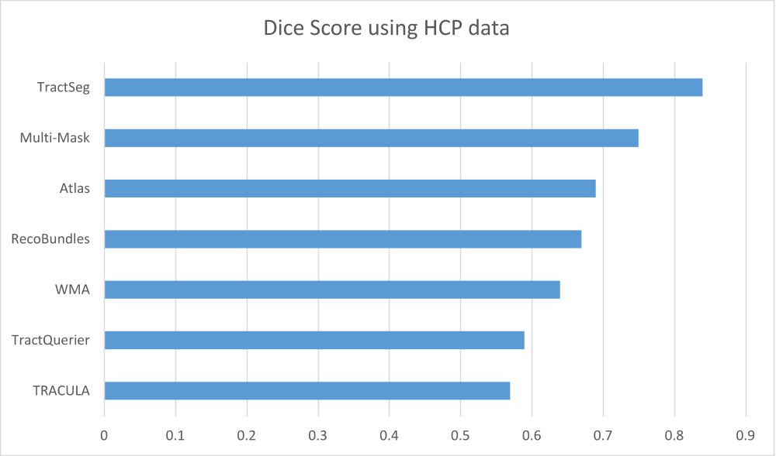

TRACULA
TRActs Constrained by Underlying Anatomy (TRACULA) uses probabilistic tracking and a predefined atlas of the underlying anatomy to segment tracts. This tool offers the opportunity to automatically reconstruct white matter bundles without requiring expert manual parcellation. This is valuable for its ability to derive white matter segments that deviate from standard atlases. For example, patients with brain injury such as hippocampal sclerosis where differences between the injured brain and healthy tract tissue characteristics can be studied[6]. Noticeably, TRACULA provides the weakest Dice Score of comparable tractography technologies. The weaknesses could stem from the probabilistic approach to parecellation.
TractQuerier
TractQuerier provides a White Matter Query Language
(WMQL) designed to extract tracts based on where streamlines start, end, and pass through. This method makes it possible to anatomically label white matter anatomy across patients. A key differentiator of this technology is found in its ability to textually
label anatomical structures that have not been catalogued. This is different from other
common approaches to automatic extraction of white matter tracts because it does not
rely on fixed sets of anatomical definitions [15].
WhiteMatterAnalysis (WMA)
WhiteMatterAnalysis clusters streamlines across subjects and generates a cluster atlas. Clusters are assigned to anatomical tracts manually, and future anatomical tract delineation is made by registering new subjects to the atlas. A pre-trained cluster atlas is provided by the tool, however there is only a small number of tracts (10) within the atlas. There are two weaknesses in this tool: The low tract count (and significant manual effort required to expand the atlas), as well as the computational resources required to identify new clusters [8].
RecoBundles
RecoBundles can be used to find streamlines in a subject based on tracts from a strong anatomical reference subject. One of the objectives of this tool is to reduce the number of invalid streamlines and white matter bundles to defend against biases in tractometry analysis [3]. RecoBundles is useful for detecting deformed and interrupted bundles going through or around tumor areas due to its ability to adapt to sharp changes or incomplete data. RecoBundles uses supervised machine learning, and relies on a reliable bundle model as input to detect relevant bundles.

Atlas Registration
Fractional Anisotropy maps of several subjects can be averaged to an atlas to produce a probability map in which to base future subject segmentation. The pipeline steps needed to produce this atlas is complex, computationally intensive, and tedious to _ne tune, however, it will produce a strong result if skilled anatomists are relied upon for quality checking to avoid propagation of subtle errors[16].
Multi-Mask
An alternative approach to atlas registration is to register the masks of single training subjects to a test subject instead of against an averaged atlas. This can reduce the blurring of details to some extent. While this may improve the blurring effect that can occur when registering to an atlas based on group averages, the complexity and _ne tuning required to achieve a reliable outcome still demands a complex pipeline and diligence[16].
TractSeg
TractSeg is the newest and most promising technology depicted in Figure 1. TractSeg has been used to provide complete and accurate segmentations using fully convolutional neural networks to directly segment white matter tracts. Not only is this method efficient, it is also less affected by the reduction in resolution seen in ROI and clustering based analysis[16].

Technology Roadmap
While today's tractography methods are continually developing, they hold enormous potential value to neuroscience, even though we are still unable to identify and directly measure axon connections within the brain. This lack of fidelity certainly does not mean fiber tract discovery will be abandoned, rather it is expected to improve with ever-evolving techniques. As techniques improve, the data collected is liable to play an important role in the assessment of neurological pathways in the brain.
The fundamental weaknesses in today's technology lies in both the processing time required to uncover individual patient fiber tracts, the resolution and accuracy of those tracts and a lack of gold-standard connectomics analytic techniques to extract, process and analyze the many neural fiber tracts detectable in a patient imaged with MRI. As the neuroscience community works to achieve these goals, we are seeing novel approaches to image parcellation as advances using machine-learning (ML) techniques mature into this field. An important dynamic with regards to ML approaches lies in the ability to reduce the complexity of tractography pipelines. It is possible that the strength of ML algorithms' ability to process and model diffusion data may one day result in performance levels that negate our need for a traditional tractographic-processing pipeline, possibly through future deep-learning architectures.
Ideally, tractography techniques will mature to the point where reliable and, efficient performance can be obtained at high-resolution. Ideally, neuroscientists can simply run a computational program to retrieve a data rich array of tracts in which to interrogate for possible abnormalities associated with a pathology under investigation. This could not only involve a reduction of complexity of tractography, but could also enhances interoperability of solutions, improves flexibility, and provides a foundation in which to implement new uses of tractographic data. At some point, it may be possible to consolidate solutions that exist globally into a single library of computer programs depending on the requirement. As solutions continue to evolve, a shared library or specific computer program will hopefully benefit the research community by encapsulating the internal complexity of the brain.

Current Landscape of Connectomics
Human Connectome Project

The Human Connectome Project's (HCP) stated goal is to build a “network map" that will shed light on the anatomical and functional connectivity within the heathy human brain, as well as produce a body of data that will facilitate research into brain disorders such as dyslexia, autism, Alzheimer's Disease, and schizophrenia [14] [12]. This is a 5 year project sponsored by sixteen components of the National Institutes of Health, and split in to two consortia of research institutes. This consortium that aims to characterize human brain connectivity and function in a population of 1200 healthy adults and to enable detailed comparison between brain circuits, behavior, and genetics at the level of individual subjects. The imaging data acquired for this project include four data modalities and is being made open access.
- rfMRI, resting state functional magnetic resonance imaging
- tfMRI, task-based functional magnetic resonance imaging
- dMRI, diffusion magnetic resonance imaging, and
- sMRI, structural magnetic resonance imaging
This data can be used with standard fiber reconstruction techniques to map individual
tractograms from patient samples. For example, probabilistic tractography has been applied to some of these datasets using FSL's existing probabilistic tractography approaches to generated connectomes[11].
Thousand Functional Connectome Project
There are a number of projects carrying out large scale brain MRI mapping on different populations, though none with the same aspirations as the Human Connectome
Project. The Thousand Functional Connectome project has published their dataset after gathering R-fMRI images of 1414 volunteers demonstrating a universal architecture of positive and negative functional connections [1]. The Alzheimer's Disease Neuroimaging
Initiative was initiated with the aim of advancing Alzheimer's Disease research with the distinct goals of studying each phase of Alzheimer's. Depending on the sub-study, there are between 600 and 2000 participant samples that have been imaged. In comparison, the HCP is unique in terms of the diversity of imaging modalities and the richness of the behavioral and genetic information being collected.
Clinical
Since 2007, Boston Children's Hospital (BCH) has been collecting high angular resolution diffusion data clinically with a consistent set of 3 Tesla MRI magnets. This data provides a unique opportunity to investigate the potential for studying the use of connectomics technologies in the context of what can be accomplished with clinical data. Existing connectomics projects target healthy brain development (as in the
Human Connectome Project) or Alzheimer's Disease (as in the Thousand Functional
Connectome project), however, clinical data provides unique opportunities for further analysis. Clinical data has been acquired at BCH for patients with a wide variety of medical conditions, including autism, attention-deficit hyperactivity disorder, cerebral palsy, multiple sclerosis etc. as well as including imaging of neurotypical patients. Thus creating connectomics technologies that can be applied to real-world BCH data will facilitate the investigation of possible fiber tract-based structural abnormalities associated
with a variety of medical conditions and may represent a key component playing a role
in the next generation of diagnostic clinical technologies.

Machine Learning Applications
Machine learning (ML) is a branch of artificial intelligence based on the idea that systems can learn from data by identifying patterns, making classifications, predictions, and ultimately making decisions about the data with minimal human involvement. ML solutions are typically organized into two categories: supervised and unsupervised learning.
The core objective of a ML algorithm is to generalize from data (learn) a model that can be reapplied to future data. Applications are wide reaching, especially in data rich research fields such as neuroscience or bioinformatics in general.
There are a number of ways in which machine learning can be leveraged from a neuroscience perspective. With respect tractography, TractSeg (previously discussed) has shown exciting promise both with speed of execution and accuracy. TractSeg uses a form of supervised machine learning called neural networks to uncover fiber bundles and tracts in the brain[16]. Machine Learning has been leveraged to diagnose Parkinson's disease based on supervised learning to detect sensitive biomarkers based on MR images[10]. In this research, machine learning will be used to demonstrate the viability of supervised learning to create biomarkers indicative of autism.

Techology Landscape
There are currently two approaches to understanding the axonal connections found within the human brain. Anatomical studies (such as dissection or diffusion tensor imaging) and electrostimulation mapping investigations are used to map subcortical pathways as a way to model the human brain. Understanding this axonal connectivity is crucial to build models of cognition, behavior, and even consciousness[2]. Once connectomes are produced, it is the study of the data that is most valuable. This research is based on the theory that connectomic data can drive innovation, find opportunities for detection and diagnosis and provide insights into brain disorders or brain disease.
There are a number of problems with the current state of related technology. Reliability,
computational requirements and utility of the resultant technologies are a reflection of the broad and diverse expectations of neuroscience as we seek to learn new methods to improve accuracy and consistency of the known fiber tracts within the human brain.
This research seeks to provide a connectome reporting user shell that offers a layer of abstraction from the myriad of technologies employed in biomarker extraction, including
MRI scanners, data processing techniques and brain atlases. The goal of this work is to provide the framework for a computational interface in which data can be quickly extracted and manipulated in data science tools such as Matlab, R, Python, and SPSS regardless of the state of evolution of underlying tractography techniques and connectomic data available. This research goal also involves the development of connectomic processing and analysis software tools that work on real-world clinical data from BCH.

Preliminary Discussion and Results
In January 2018, [7] illustrated the investigative potential of performing connectomics style analysis and demonstrated the feasibility of creating novel pipelines that use current technologies to perform regionally focused clinical connectivity studies. This research encouraged future functionality whereby clinical analysis of other major neural fiber tracts throughout the brain could become possible. This capability when executed at scale would enable analysis across hundreds or thousands of patient samples as we seek to understand correlations and patterns among ROIs in the entire connectome. This will provide a mechanism to discover insights, make predictions, and ultimately may create new diagnostic and disease characterization technologies for patients with autism, attention deficit hyperactivity disorder, cerebral palsy and more.

Implementation

Technology and Tools
This is a linux based solution, with a high dependency on existing computational neuroscience technology. To implement the computation pipeline, CRUSH depends on a set of freely available tools including FSL(Smith, 2004), Freesurfer(###), and TrackVis (Wedeen, 2008).

CRUSH
Connectome Reporting User SHell is a console based command line utility, developed in Python3. The objective was to combine and integrate utilities from multiple freely available tools in order to orchestrate a data processing pipeline designed to collect a combined structural (T1) and high angular resolution diffusion imaging (HARDI) analysis of all major neural fiber tracts throughout the brain.
Python was chosen for its flexibility to interoperate at the OS level, and its wide developer adoption. The software was developed on Linux Mint 19 (Tara) using a Dell XPS13. Production code has been tested and executed on Ubuntu 18.04 standalone OS as well as Ubuntu 18.04 deployed via the Windows 10 Linux Subsystem. The ComputeCanada superclusters GRAHAM and CEDAR running CentoOS7 were also used for production execution.
The data processing pipeline was based on a previous study by Levman [###]. CRUSH is designed to be recoverable, and can detect current state of pipeline execution. The command-line is relatively simple, leaving no command-line difference between an untouched set of T1 images and a partially complete patient data.
The extraction pipeline results in over 800,000 measurements (per patient) in two passes (the second pass to calculate asymmetry indexes), and stores those metrics for future recall.
CRUSH is expected to be applied against a large dataset of TI images spanning multiple patients and patient visits. The folder structure containing patient data is required to adhere to the standard outlined below:
.
├── PatientID
│ └── VisitID
│ ├── Freesurfer
│ │ ├── …
│ │ ├── mri
│ │ ├── …
│ ├── Tractography
│ │ ├── …

Each visit has two mandatory directories for the T1 and DTI data. These directories are Freesurfer/mri and Tractography. CRUSH will ignore any directories that exist but don’t appear to be relevant. The user is expected to pass the root directory containing all patient samples as a mandatory parameter.

User Interface
CRUSH has a command line interface intended for batch processing and scheduling. On current hardware using a 32-core CPU with 64GB of RAM and SSD drives, a single patient renders fully in approximately 8 hours if Trackvis logging is disabled, so the expectation is this tool will traditionally be executed and left alone to process the patient data.
Command Line:

usage: crush.py [-h] [-samples SAMPLES] [-status] [-recon] [-norender]
[-rebuild] [-patient PATIENT] [-voi VOI] [-recrush]
[-fixmissing] [-report] [-columnar] [-metadata METADATA]
[-maxcores MAXCORES] [-disable_log]

Connectomics and Reporting User Shell is used to iterrogate samples, generate
or extract measurements.

optional arguments:
-h, --help show this help message and exit
-samples SAMPLES Path to patient samples
-status Report back what is out there and what needs to be done
-recon Apply recon-all for any T1.mgz found beneath working
folder
-norender If there are incomplete connectomes, ignore the
outstanding work
-rebuild Recreate any intermediary files used for establishing
measurements. If this not specified, any intermetiate
files found with the appriate file name will be left
untouched.
-patient PATIENT Specify patient ID of interest if focusing on a single
patient
-voi VOI Values of Interest - Path to text file that lists values
of interest to extract. One column per line. Look at any
patient sample tractography\crush\tracts.txt file for
measures.
-recrush Ignore anything previosly crushed and re-extract tract
information
-fixmissing Ignore anything previosly crushed and extract only tract
information that has not been rendered yet
-report Extract a row-based table for analysis, 1 row per
measure
-columnar Extract a column-based table for analysis, 1 row per
patient
-metadata METADATA Path to metadata file about patient. The metadata file
should have the CSV format Patient,Visit,Attr1..AttrN
-maxcores MAXCORES Maximum number of cores to use while deriving
measurements. Use this if you want to leave a little CPU
room left for other processing. By default, all cores
will be used (36 cores on this machine).
-disable_log If specified, disable track_vis.log

The tool is capable of processing all patients without specifying each patient to render (-patient switch), however given the heavy processing required, it has been helpful to split patient data into work packages across multiple nodes. For example, render all patients from 0100-0199 on a specific node or cluster. A basic bash script can accomplish this as seen below.
#!/bin/bash
PREFIX=""
for i in {621..629}
do
printf -v patientID "%04d" $i
echo "echo processing $patientID"
python3 ~/projects/crush/crush.py -maxcores 24 -samples \
~/projects/todo -patient ${patientID} \
-fixmissing -disable_log >~/projects/logs/${patientID}.log
done

Measurement Extraction Pipeline
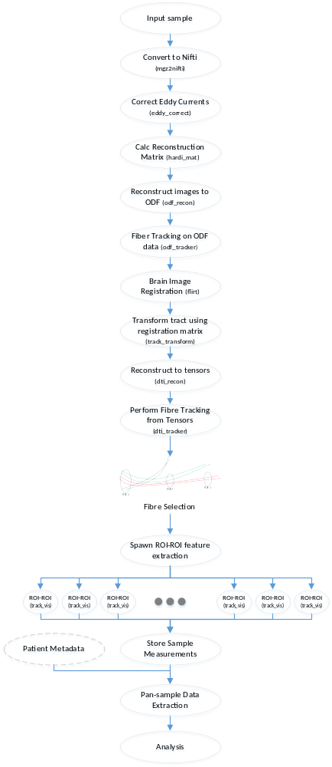The measurement extraction pipeline is a novel approach derived and validated in (Levman, 2017). The sequence depicted in Figure 1 - Processing Pipeline outlines the steps taken to derive tensor fibre tracts using a combination of FSL, FreeSurfer, and TrackVis command line tools.
Figure 1 - Processing Pipeline
Images were converted to Nifti format and then corrected for eddy currents and patient movement.
HARDI reconstruction was performed to create whole brain tract pathways by processing the diffusion MRI data in its native input space. ODF data is reconstructed and then fibre tracking is performed to produce a track file usable by TrackVis. Each region of interest (ROI) was matched with every other ROI for the existence of fibre tracts. If a tract existed, the following measurement information was extracted and stored:
- meanFA
- Number of Tracts
- Tract Length
- meanADC
At the point where inter-ROI tensor fibres were constructed, the following measurements were captured:
Mean FA
y can be measured in terms of aggregate values such as number of fibers, tract length, fractional anisotropy, and apparent diffusion coefficent.
Diffusion MR images were aligned to FreeSurfer output space (computed from T1 examinations) using FSL's flirt-based image registration to compensate for spatial misalignment between diffusion and T1 images (Jenkinson and Smith, 2001; Jenkinson et al., 2002). FA and ADC images were computed using dti_tracker (Wang et al., 2007) for the left and right hemisphere's white and gray matter of the insula respectively. HARDI reconstruction was performed with an angle threshold of 45 degrees to generate whole brain tractography pathways of each patient by processing the diffusion MRI data in its native input space. The resultant tractography pathways were transformed into FreeSurfer output T1 space using the registration transformation previously computed by FSL flirt with the track_transform algorithm (Wang et al., 2007). Each tractography file was opened for viewing in TrackVis (Wang et al., 2007) and all examinations with visually assessed neural fiber tract reconstruction errors were excluded from the analysis (this includes exams where major neural fiber pathways are visually absent etc.), along with examinations for which the diffusion MRI to T1 alignment was visually observed to fail. This yielded 642 examinations that included both diffusion MRI and volumetric T1.

…All of the preprocessing steps are rendered

CRUSH iterates a patient sample directory looking for opportunities to execute its pipeline. When a viable sample is detected, the pipline is executed with the final goal of 100% measurement extraction.
It is possible to extract specific ROI data if only specific ROIs or specific measurements are required. For example, of only the measuresments meanADC between 4018 and 4035, and meanFA between 0254 and 2002 were required for patients, the –voi switch can be used to narrow the processing time. This switch requires a file to be passed specificing exactly which ROIs and measurements are sought. The file might look like Figure 2, in which case only those specific measures in those ROIs will be derived.
4018-4035-roi-stddevADC
0254-2002-roi-meanFA

Figure 2 - Sample voi file

During the final TrackVis stage, regions of interest that will be processed are defined in the segmentMap.txt file. This file is typically not expected to be changed, and represents the atlas numbers [TODO I need an origin of these numbers – it’s not color lut]. The TrackVis stage performs a cartesian product of all regions of interest across the roi and roi_end methods available in TrackVis, resulting in approximately 65000 intesection points (180 ROIs x 180 ROIs x 2 methods).
For each intersection, track_vis produces a text output that is parsed for measurements using regular expressions.
Number of tracks: 2454806
Number of tracks to render: 0
Number of line segments to render: 0
Mean track length: 0.00 +/- 0.00 mm

Volume dimension: 256 256 256
Voxel size: 1.000 1.000 1.000

CRUSH evaluates the version of utilities integrated in the pipeline and warns if the version of the utility is different than what was used for testing. This is intended to warn the user in the event the search terms used during regular expression evaluation need to but updated.

Data
[TODO] Introduce this section

Patient Data
[TODO] Description of Patient Data

Capture Hardware
The clinical T1 imaging approach used in this study has been previously presented by (Levman et al., 2017). The dataset for Levman’s study was carried forward so it could be extended beyond the focus of the insula. In Levman’s study, all participants were imaged with clinical 3 Tesla MRI scanners (Skyra, Siemens Medical Systems, Erlangen, Germany) at Boston Children’s Hospital yielding T1 structural volumetric images accessed through the Children’s Research and Integration System (Pienaar et al., 2014). Any samples with substantial motion artifacts or failure during FreeSurfer processing were previously removed.
Levman’s study included Diffusion MRI data acquired using isotropic diffusion-weighted spin-echo echo-planar imaging. Thirty diffusion-weighted measurements (b = 1,000 sec/mm²) and five non-diffusion-weighted measurements (b= 0 sec/mm²) were acquired with TR= 10 sec; TE= 88 msec; δ= 12.0 msec; Δ= 24.2 msec; field of view= 22 x 22 cm; matrix size= 128 x 128, iPAT= 2, spatial resolution 1.72 x 1.72 mm.

Measurement Data
After a patient has been processed, a new “crush” directory will exist beneath the Tractography directory. This directory contains a single tracts.txt file representing each measurement derived during the pipline. The first few lines of the tracts.txt file is shown in Figure 3. This data set is structured in the form of name-value pairs. This makes it easy to later retrieve an individual measurement with basic unix command line tools (awk,sed, or grep).
0013-3010-roi-LinesToRender=18645
2013-2015-roi_end-MeanTractLen=0
4018-4035-roi-stddevADC=0.00017615198858183018
0254-2002-roi-meanFA=0.3647475153452198
0049-2027-roi-LinesToRender=78612
2021-4015-roi-TractsToRender=786
0008-3028-roi_end-MeanTractLen=0
0046-0050-roi-meanADC=0.0007841976048825862
0062-1035-roi-LinesToRender=0
3029-5002-roi_end-VoxelSizeZ=1.000
…
Figure 3 - Sample tracts.txt file

Individual ROI-to-ROI files exist in .json format to support restartability or alternate methods of retrieval in future applications. The files are stored according to the beginning ROI. For example, to view all data relevent to the intersection of ROI 0013 and ROI END 3010 using the roi track_vis method, the file Tractography\crush\0013\calcs-0013-3010-roi.json may contain data similar to Figure 4.
{"0013-3010-roi-TractsToRender": "38", "0013-3010-roi-VoxelSizeX": "1.000", "0013-3010-roi-stddevADC": 0.00015906886621198937, "0013-3010-roi-stddevFA": 0.22448023841440762, "0013-3010-roi-NumTracts": "2454806", "0013-3010-roi-meanADC": 0.0007865246391972348, "0013-3010-roi-LinesToRender": "18645", "0013-3010-roi-VoxelSizeY": "1.000", "0013-3010-roi-meanFA": 0.4930457186118099, "0013-3010-roi-MeanTractLen": 0, "0013-3010-roi-MeanTractLen_StdDev": 0, "0013-3010-roi-VoxelSizeZ": "1.000"}

Figure 4 Sample data file: calcs-0013-3010-roi.json

Extraction

CRUSH provides a command line parameter to extract all patient data to a single output file. It can do this in two ways, depending on the shape of the output desired. A columnar –columnar switch can be passed on the command line to extract output with one row representing a patient visit, and all measurements represented as columns. This is useful for scenarios such as PANDAS data manipulation in Python. There are approximately 800,000 columns produced in this format. The individual measurements as well as their left-right asymmetry indexes are returned. Generally speaking, the traditional tools used for analysis (MATLAB, R, Tableau, etc.) do not perform well with such a wide data set.
If the –report switch is passed instead of the –columnar switch, all patient data is returned where one row represents a specific intersection of ROIs using one track_vis method (-roi or –roiend). E.g. ROI starting at 0254, ending at 2002 using the –roi method. The columns on that row represent all measurements retrieved for that intersection (shown in Figure 4 Sample data file: calcs-0013-3010-roi.json ) along with the left-right asymmetry indexes for each measure. This would be the equivalent of a “tall” table in MATLAB.

SQL Access
To make this data set more accessible, ETL using Microsoft SSIS was written to load the data into a MS SQL server database. Performance of data set manipulation can be significantly improved by offloading set manipulation to SQL server database, leaving more memory and CPU resources available on the client. In fact, the most responsible and nimble access to data was best when using Tableau with data loaded into an indexed table in SQL Server.

Demonstration of Analysis
Summary Statistics
Box Plots
Visualizations
Machine Learning
Python Examples
Matlab Examples

System Architecture
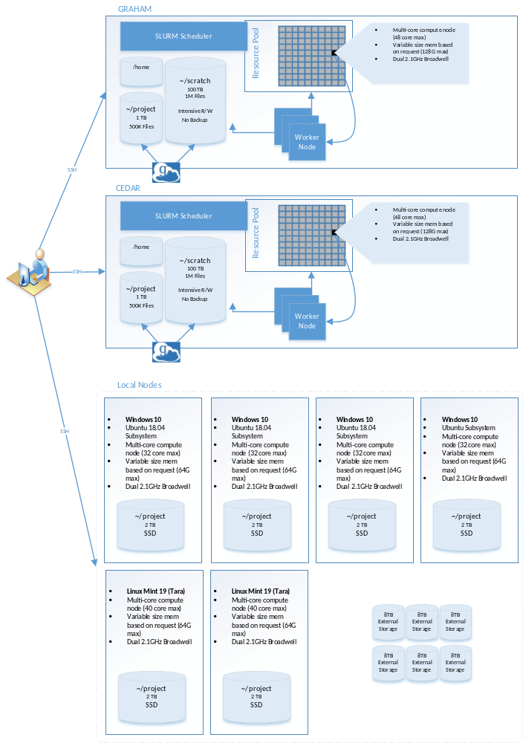

Conclusion

Results – Testing, Statistics, Proof of Accuracy
[TODO] Lorem ipsum – Compare to Insula paper once data is completed

Challenges and Issues Encountered

Resource Limitations
The most significant challenge with this initiative was finding enough compute resources to process the pipeline. Each phase of the pipeline has different computing requirements, depending on the phase. Further, each type of hardware used to compute the results performed differently. As a result, the resources requested on Compute Canada clusters tended to appear under-utilized after completion. There were times when we requested 32 cores and only used 1 core over several hours. This resulted in requesting more resources than necessary (when viewed in aggregate), and having to wait for time on the scheduler to receive those resources. E.g. a request for a whole node (32 core, 128GB memory) was the least likely to abend, but also hardest to obtain from the scheduler.
For the early phases of the pipeline (1-8), the tasks do not take advantage of parallelism because of the interdependency of the data, each step building off the previous. As well, the utilities used in the pipeline do not provide parallelism switches to take advantage of multiple cores. A perfect machine for phases 1-8 has a CPU with a high clock speed and RAID 0 or RAID10 disk. Multiple cores are wasted this phase, all of the tasks are single threaded.
The fibre tracking step (step 9) was written to take advantage of all cores available on the computer. An optional switch (-maxcores) was provided to force a maximum number of cores used to allow the machine to perform adequately for other functions. The perfect machine in this phase is a high number of cores, 2GB RAM per core. Configurations with less than 2GB memory/core resulted in out of memory errors.
Table 1 - Pipeline Compute Requirements
# | Phase | Duration | Computing Requirements
1 | Convert input files to NIFTI format | [TODO] | [TODO]
2 | Correction for distortion and subject motion
3 | Calculate the reconstruction matrix from a given gradient table
4 | Reconstruct raw images to ODF with a given pre-calculated recon matrix
5 | Perform fiber tracking from the reconstructed odf data and output a track file for TrackVis
6 | Brain image registration using FSL
7 | Transform the tract using registration matrix
8 | Reconstruct raw analyze images to tensors
9 | Perform fiber tracking from the reconstructed tensors |  | Parallel, High CPU,
10 | Extract data set

CEDAR
Available disk space to stage the data was very limited on the CEDAR cluster. The maximum number of patient visits that could fit on the available scratch space was 10. The project disk space was larger but considerably slower. It took approximately 48 hours to process a single sample when project disk was used. To rsync the data from project to scratch took approximately 5 hours per patient. If using rsync to scratch, to compute a single sample on cedar after mirroring data to the scratch disk took approximately 26 hours of elapsed time. This became further complicated if the task failed (e.g. scheduled time expired or out of memory errors). Keeping a partially rendered sample and restarting from the point of failure was challenging because it required individual investigation to understand root cause, and assessment of whether a restart is viable. In some cases it was necessary to perform a manual repair if needed (e.g. corrupt output file due to out-of-memory) to not lose time.

GRAHAM
The GRAHAM cluster was more reliable than CEDAR and offered more space on the scratch disk, however not all patient samples could fit, and it was not safe to leave samples on scratch, since that space is routinely purged of untouched files after 60 days. As a result, only 100 samples were put on GRAHAM. Requesting a whole node to compute samples introduced time delays, since the SLURM scheduler could go days without providing a single job execution.

Alienware
There were three Alienware servers available near the end of the project. These machines were configured with Windows 10 Pro and the Ubuntu linux sub-system. Ubuntu 18.04 was available, and the recommended OS for FSL, Freesurfer, and Trackvis. There were technical issues with the available version, and required some OS configuration to ensure shared objects were available. Once configured, the system could render a patient sample in approximately 11 hours, 45 minutes. This configuration was reliable and predictable, but there were only three nodes (initially only one), which meant 12 samples could be completed per day. Uninterrupted, it would take approximately 2 years to complete all samples using those nodes. Since these machines were on-domain, they frequently required windows updates, which required a restart approximately every few weeks.

Dell Precision Tower (40 core)
The most stable platform to execute the pipeline was the Dell Precision Tower (40 core) running Linux Mint 19 (Tara). This unit is capable of rendering the entire pipeline in just over 8 hours. This unit was only available in the last two months of the project, and a second was available in the past few weeks.
Windows 10, linux subsystem: 11 hours, 45min

Disk Contention
None of the compute resources available had disks configured for high I/O performance, and there were a number of cases where a high degree of spindles across multiple controller cards could have greatly improved performance. Step 9 of the pipeline writes output of each intersection point to support recoverability of the process. This is a highly parallel step, processing 32000 intersections per sample. Each process executed in this step performed a disk read, then CPU intensive activity, then a disk write to store the result. 32,000 files are produced in total. In early versions of the code, searching the inode table for the correct files appeared to be adding disk contention and high disk-waits. The code was modified to use a taxonomy structure for these temporary files, which somewhat improved the performance of step 9.
Additionally, there is limited documentation online for the track_vis utility command line switches. It wasn’t apparent until late in the project that a –disable_log switch existed. This allowed the trackvis.log file to be ignored, and significantly improved performance and reduced disk waits.

Proposed Enhancements

Map Reduce
Lorem ipsum

REDIS
Lorem Ipsum

Improved Fault Detection
Lorem Ipsum

Add Pre-Pipeline Phase
Lorem Ipsum

Final Remarks
sdfdsfds

